**Touch**

**Typing**

**Class Five**

**Lab 11**

|  |
| --- |
| Lab Objectives:  * Introducing Letters: V  B  N  M |

# Finger Placement

## You are now advancing to bottom row letters.  These will be a bit more challenging but they are yours for the taking.  Just keep up the practice and before you know it, they will all be under your command.

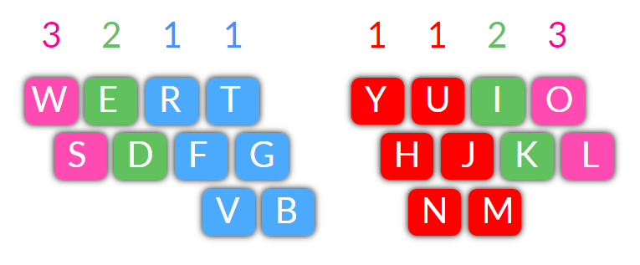

## Here's a few to get you started: *home, newest, mother. love, verify, west, justly, oven, bike*

# Exercises - 1

## Use your LEFT HAND INDEX FINGER (No. 1) for V and B

## Use your RIGHT HAND INDEX FINGER No. 1) for N and M

# IMG_256

# Both Hands

 fvf frfvf fbf frfbf rev vet fvf frfvf fbf frfbf rev vet

 five fiver fib fibber fibre very every five fiver fib fibber fibre very every everyone

 jmj jujmj jnj jujnj jmj jujmj jnj jujnj

 jim him kim tim rim trim hem them jim him kim tim rim trim hem them

 jnj jujnj tin fin din dint tint jnj jujnj tin fin din dint dinted tin tint tinted

# Exercises - 2

## Focus on TOP ROW VOWELS with V, B, N and M

## IMG_256ou ough rough tough trough enough ou ough rough tough trough enough

## though thought through thorough though thought through thorough

## mouse mousey mount mound mounds mouse mousey mount mound mounds

## round rounds sound resounded round rounds sound resounded bound rebound

## ion lion mention vision visions ion lion mention vision visions enliven enlivens

# Fun Phrases

## savvy john johnston bravely mentioned the lions and tigers; they looked very tough;

## the little brown mouse went round the house which stood beside the high mound;

## i remember the big mission home which is built on the high ground beyond the valley;